## Biochemical principles

1. **Compare and contrast the major non-covalent forces: H-bonds, hydrophobic effect, ionic bonds, Van der Waals interactions**
   1. H-bonds: O, N and OH, NH. 20kJ/mol Gibb’s free energy
   2. Hydrophobic effect: occurs between large, nonpolar molecules
   3. Ionic: between charged molecules
   4. Van der Waals: between large molecules
2. **Define enthalpy and entropy and explain how the changes in both contribute to Gibbs energy**
   1. Gibb’s energy is enthalpy minus entropy.
   2. In the hydrophobic effect, the separated state has more enthalpy, since there are more hydrogen bonds and they have a cage-like structure. The joined state has more entropy, since the water molecules are able to move more freely.
3. **Compare and contrast delta G knot and delta G, and how they relate to Keq**
   1. Delta G = Delta G knot + RTln[B]/[A]. That is, Delta G tells you how far you are from Delta G which is equilibrium
   2. Delta G = 0 means you are at equilibrium, Delta G knot = 0 means 50/50 at equilbrium
4. **Describe the properties of water that determine the conformation of a biological molecule and facilitate interactions between biological molecules**
   1. Hydrogen bonds because of polarity. Hydrogen interactions are also directional.
5. **Define pH**
   1. Measures proton concentration
6. **Estimate the proportion of protonated/deprotonated molecules at various pHs**
   1. At pKa, 1:1. For each pH down 10x more protonated, and for each pH up, 10x more deprotonated. At a lower pH, excess H+ in solution, so will get protonated. At a higher pH, donate proton to solution.
7. **Estimate the ratio of acid/base forms of a molecule when given sufficient information, and explain how this ratio is related to pKa and pH**
   1. How many magnitudes away from pKa? For each magnitude, 10-fold difference.
   2. If below pKa, more protonated because more willing to take protons from environment. If above pKa, more deprotonated since more willing to share protons.
8. **Draw and interpret panels of populations of molecules in reference to the equilibrium**
   1. A ←→ B, K_eq = [B]/[A]
   2. Favor products if Keq > 1, favor reactants if Keq < 1
   3. 10 fold difference in concentration corresponds with 5kJ/mol Gibb’s
   4. If more products, Gibb’s is negative. If more reactants, Gibb’s is positive.
9. **Predict the behavior of polar, apolar, and amphipathic molecules in aqueous environments**
   1. Amphipathic molecules, nonpolar will have hydrophobic effect

## Protein Structure

1. **Given the full name, three letter code, one letter code, or structure of an amino acid, list or draw the other three**
   1. 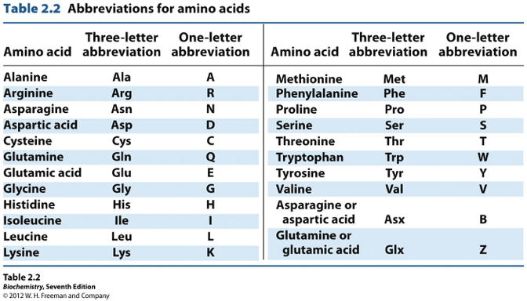
   2. 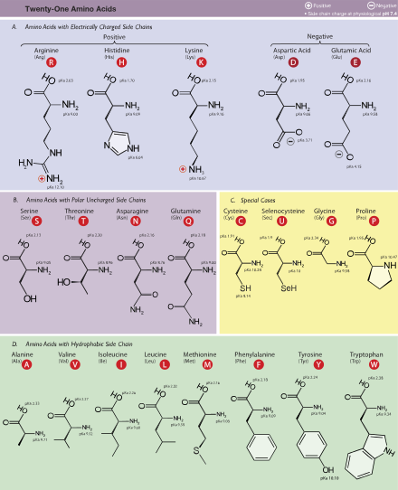
2. **Identify amino acids (structure, pKa) and apply knowledge of their characteristics (hydrophobicity, size, shape)**
   1. 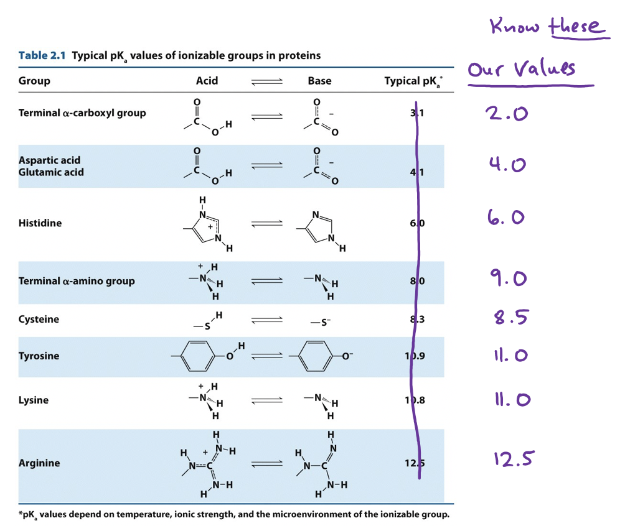
3. **Describe the properties of a peptide bond**
   1. Formation removes a water
   2. Double bond resonates, preventing rotation
   3. 9B identify
4. **.**
5. **Draw the molecular structure of a peptide. Identify the correct ionization states and calculate the charge at a given pH**
   1. At pKa, +/-0.5 depending on whether the molecule goes from (neutral to negative) or (positive to neutral)
6. **Compare and contrast protein purification techniques discussed in class, and propose, interpret or predict results of protein purification techniques**
   1. Isoelectric focusing: negatively charged molecules need many protons to be neutral, so will go to low pH. Positively charged molecules few protons to be neutral, so high pH.
   2. Ion chromatography: cation has negative beads that attract positive, anion has positive beads that attract negative. Choose a pH between pIs.
   3. SDS-Page: small molecules move faster, smaller elute first. Denatures protein, gives it uniform negative charge.
   4. Size exclusion/gel filtration: small molecules get stuck in matrix/beads, bigger elute first. Does not prevent molecules sticking together.
7. **Explain how identical protein molecules reliably adopt the same structure**
   1. Anfinsen experiment
   2. Hydrophobic effect, determined by primary structure, helps determine native state
   3. Allowing cysteine to form bridges first ends up with scrambled state
8. **Identify covalent and non-covalent interactions between amino acids that affect the conformation of a protein**
   1. Primary structure - amino acid chain
   2. Secondary structure - alpha helices and beta sheets
      1. Beta: R groups alternate face up and down. NPNPNP
      2. Alpha: R groups face away from center of helix NPPNPPPN
      3. Turns - small molecules in turns
      4. Loops
      5. In beta and alpha, R groups hydrogen bond together, but beta more likely to aggregate because they are non-specific, they do not a particular primary structure to aggregate
   3. Tertiary structure - protein folding
      1. Cysteines can form disulfide bonds
      2. Hydrophobic can get pushed to the inside
   4. Quaternary structure - protein subunit interactions
9. **Predict hydrogen bonding interactions that occur in alpha helices and beta sheets**
   1. Alpha: Hydrogen bonds between the backbone (between *i* and *i+4*) bind the helix together, with CO’s pointing towards the C terminus and NH’s pointing towards the N terminus.
   2. Beta: Hydrogen bonds between the backbone bind multiple sheets together. Antiparallel is more stable than parallel.
10. **Represent protein folding as an equilibrium and describe the relative contributions of different forces on the overall equilibrium constant**
11. **List factors that favor protein folding or unfolding (enthalpy, entropy, temperature, pH). Predict the effect of changing those factors on protein folding, interactions, and binding**
12. **Describe possible outcomes of protein misfolding**
    1. No active binding site, lose its function
13. **Describe the mechanism of how specific molecules (detergents, reducing agents, or proteins) affect folding**
    1. Detergents: cover hydrophobic regions
    2. Reducing agents: denatures, e.g. mercaptoethanol and disulfide

## Protein function

1. **Explain how changes in protein sequence might affect protein structure and function**
   1. Proline can break secondary structure
   2. Nonpolar versus polar can affect hydrophobic effect
2. **Define binding affinity and Kd**
   1. Binding affinity: strength of two molecules binding together. High binding affinity means that a molecule will stick to it, e.g. R state binds O2 well
   2. Kd: dissociation constant. high dissociation means that molecules do not stick easily, e.g. T state’s high Kd means that O2 will not stick easily to it.
3. **Draw and interpret a binding plot and label the Kd**
   1. Kd is 50% fractional saturation
   2. Shift to the right means higher dissociation and lower binding affinity, while shift to the left means lower dissociation and higher binding affinity
4. **Apply principles of equilibrium to protein function**
   1. Kd = [P][L]/[PL]. This can be useful, since you can move [L] to the other side, and this tells you the relative concentration of P and PL.
5. **Compare and contrast myoglobin and hemoglobin**
   1. Myoglobin is a monomer with no allosterics, hemoglobin a tetramer with cooperative binding
   2. Myoglobin curve is rectangular hyperbola, while hemoglobin is more S shape.
6. Explain the role of allostery, cooperativity, and conformational change in hemoglobin function
7. List ways proteins can be regulated and describe specific examples
8. Predict the impact of a ligand on a given equilibrium and on protein function
9. Predict the effects of molecules (BPG, proton, CO2) on hemoglobin cooperativity and describe the physiological importance of each